**Roll no: CB.EN.U4CSE18243**

**(15CSE302)**

**Data Base Management Systems**

**Lab Exercise 1**

1. **Customer Master Table:**

create table cust(

custid varchar2(3) NOT NULL,

Lname varchar2(15),

Fname varchar(15),

area varchar2(2),

phoneno number(8),

CONSTRAINT cid_pk PRIMARY KEY (custid)

);

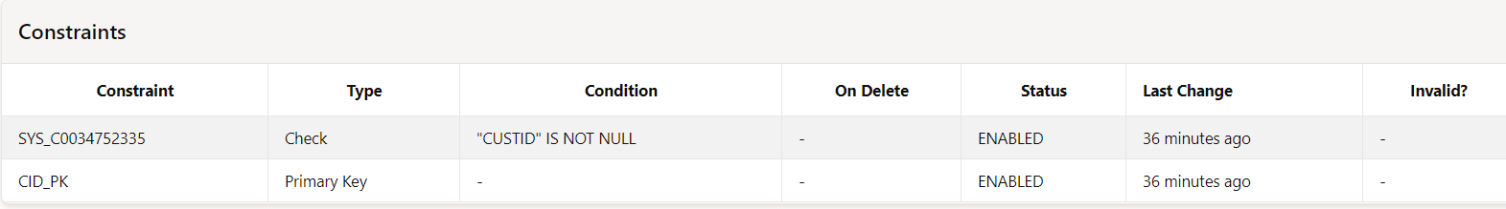

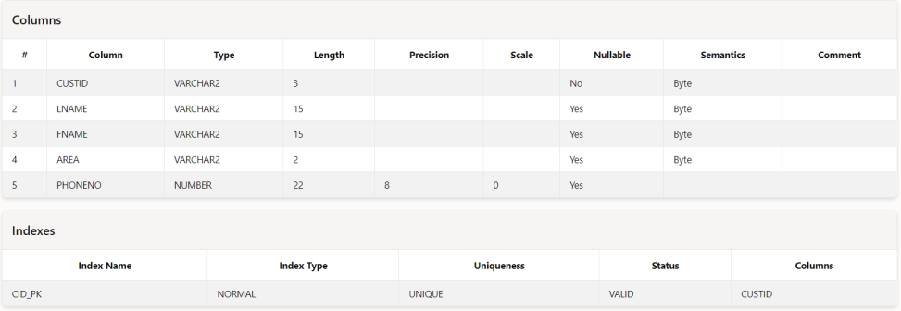

**Customer Table :**

insert into cust values ('A01','Bayross','Ivan','sa',6125467);

insert into cust values ('A02','Saitwal','Vandana','mu',5560379);

insert into cust values ('A03','Jaguste','Pramada','da',4563891);

insert into cust values ('A04','Navindgi','Basu','ba',6125401);

insert into cust (custid,Lname,Fname,area) values ('A05','Sreedhar','Ravi','va');

insert into cust (custid,Fname,area,phoneno) values ('A06','Rukmini','gh',5125274);

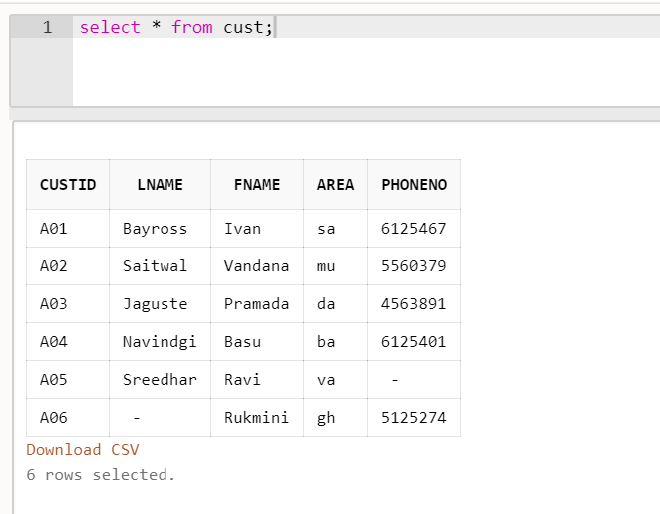

2. **Movies Master Table:**

create table movie(

Mvno number(2) NOT NULL,

title varchar2(25),

movieType varchar2(10),

star varchar2(25),

price number(8,2),

CONSTRAINT mvno_pk PRIMARY KEY (Mvno)

);

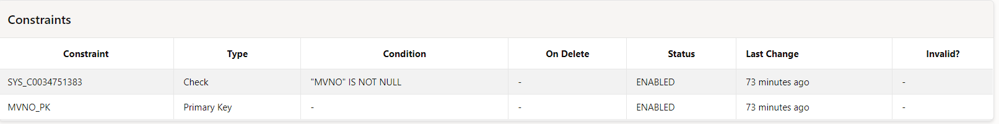

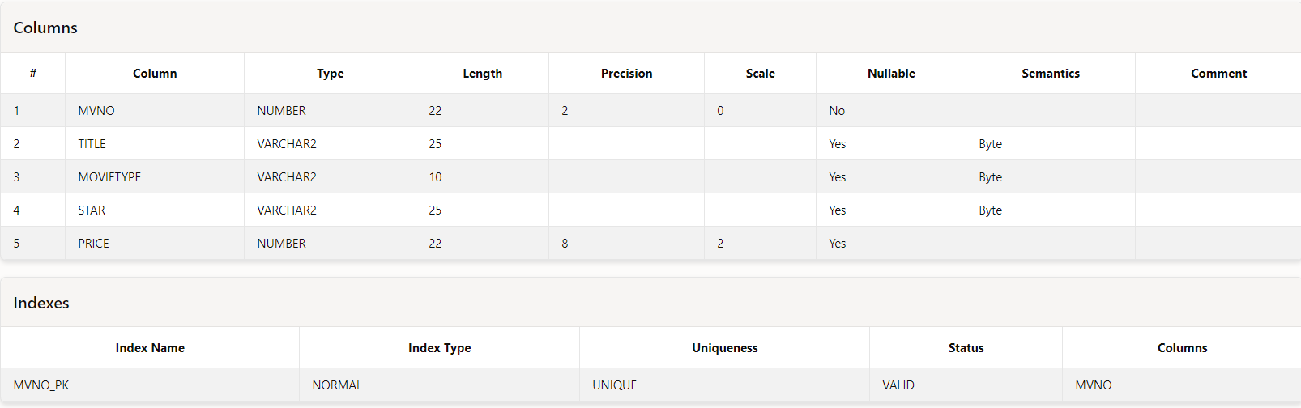

**Movie Table:**

insert into movie values (1,'Bloody Vengeance','action','Jackie Chan',100.00);

insert into movie values (2,'The Firm','thriller','Tom cruise',200.00);

insert into movie values (3,'Pretty Woman','romance','Richard Gere',150.00);

insert into movie values (4,'Home Alone','Comedy','Macaulay Culkin',150.55);

insert into movie values (5,'The Fugitive','Thriller','Harrison Ford',200.00);

insert into movie values (6,'Coma','Suspense','Michael Douglas',100.00);

insert into movie values (7,'Dracula','Horror','Gary Oldman',150.25);

insert into movie values (8,'Quick change','Comedy','Bill Murray',100.00);

insert into movie values (9,'Gone with the wind','Drama','Clarke Gable',200.00);

insert into movie values (10,'Carry on Doctor','Comedy','Leslie Phillips',100.00);

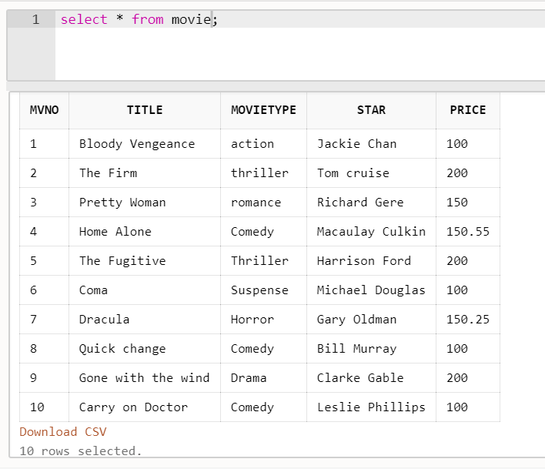

3. **Invoice transaction Table :**

create table invo(

Invo varchar2(3) NOT NULL,

mvno number(2),

Custid varchar2(3),

issueDate char(9),

retDate char(9),

CONSTRAINT invo_pk PRIMARY KEY (Invo),

CONSTRAINT mv_fk FOREIGN KEY (mvno) REFERENCES movie(Mvno),

CONSTRAINT cust_fk FOREIGN KEY (Custid) REFERENCES cust(custid)

);

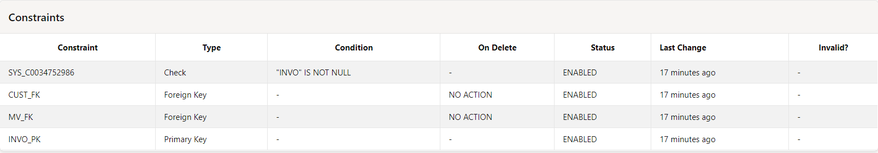

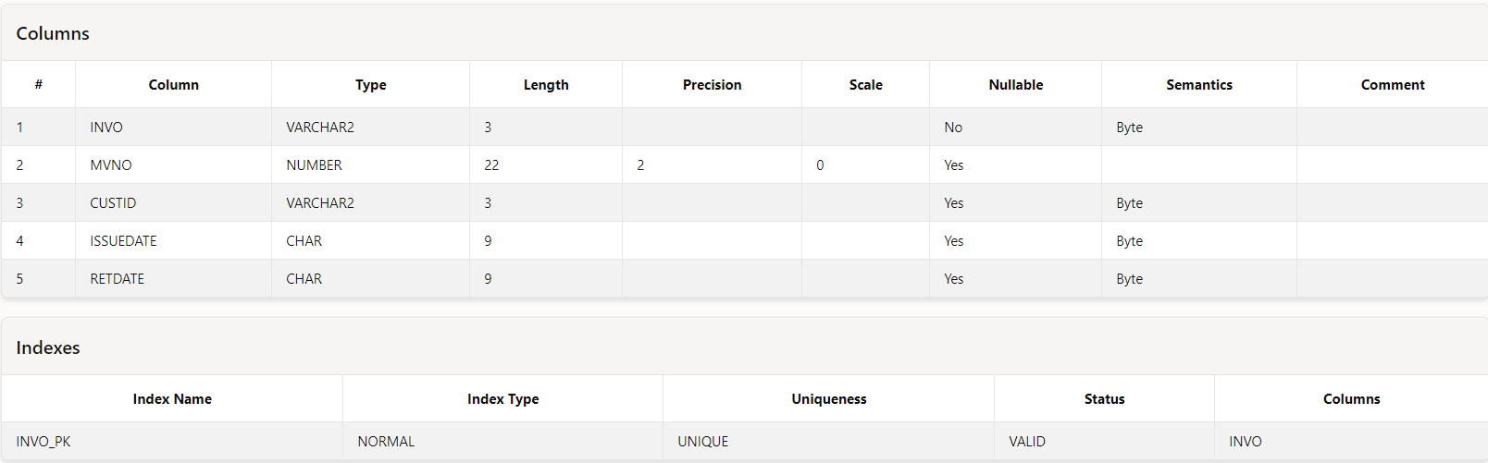

**Invoice Table :**

insert into invo values ('I01',4,'A01','23-jul-93','25-jul-93');

insert into invo values ('I02',3,'A02','12-aug-93','15-aug-93');

insert into invo values ('I03',1,'A02','15-aug-93','18-aug-93');

insert into invo values ('I04',6,'A03','10-sep-93','13-sep-93');

insert into invo values ('I05',7,'A04','05-aug-93','08-aug-93');

insert into invo values ('I06',2,'A06','18-sep-93','20-sep-93');

insert into invo values ('I07',9,'A05','07-jul-93','10-jul-93');

insert into invo values ('I08',9,'A01','11-aug-93','14-aug-93');

insert into invo values ('I09',5,'A03','06-jul-93','09-jul-93');

insert into invo values ('I10',8,'A06','03-sep-93','06-sep-93');

